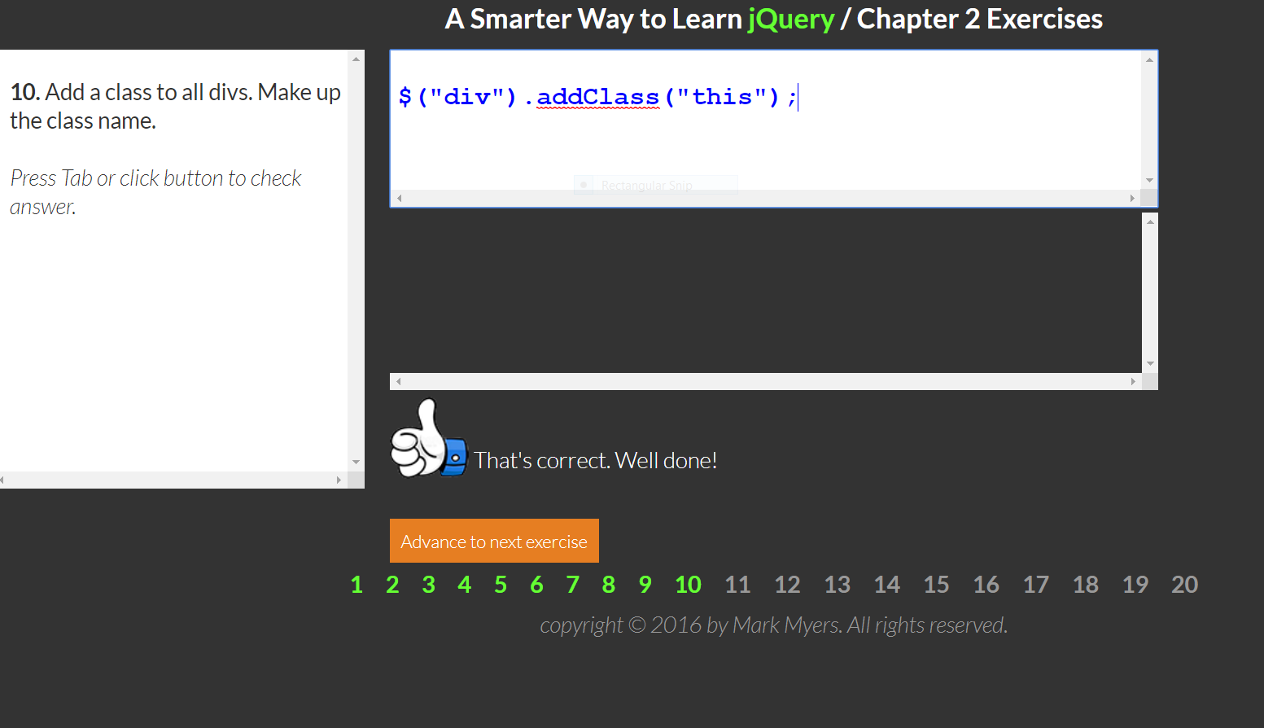

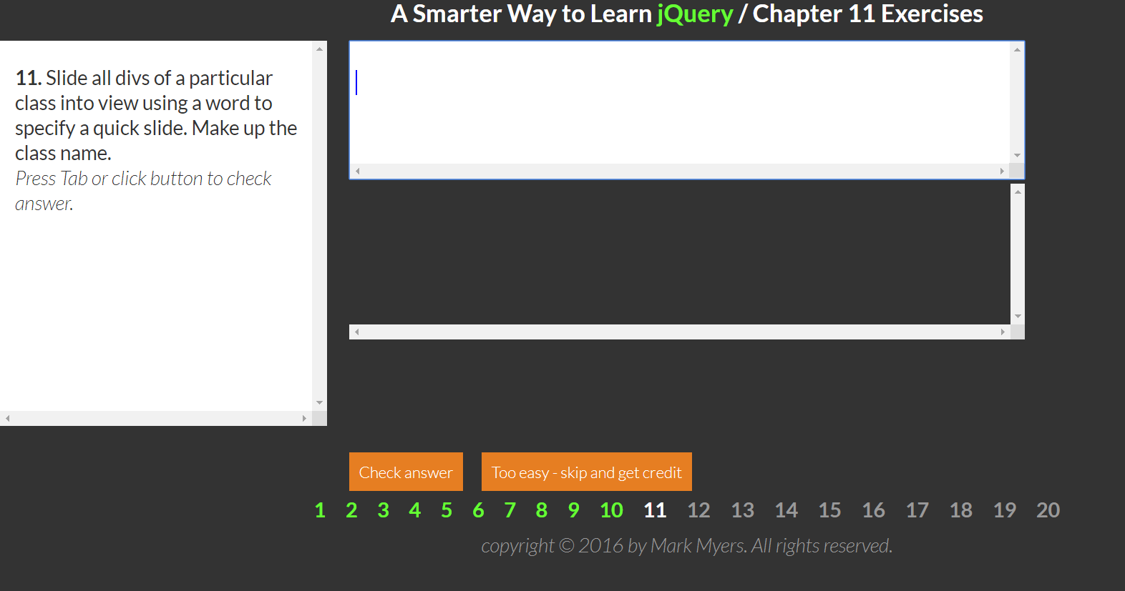

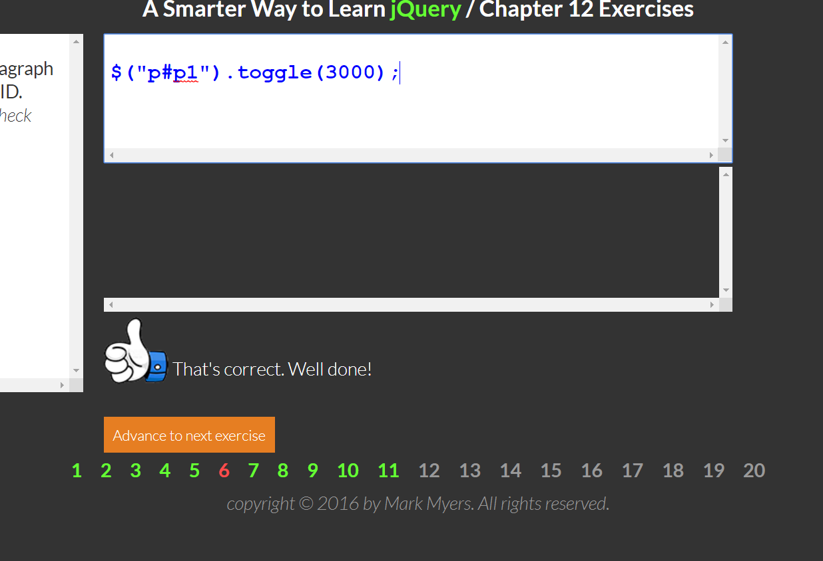

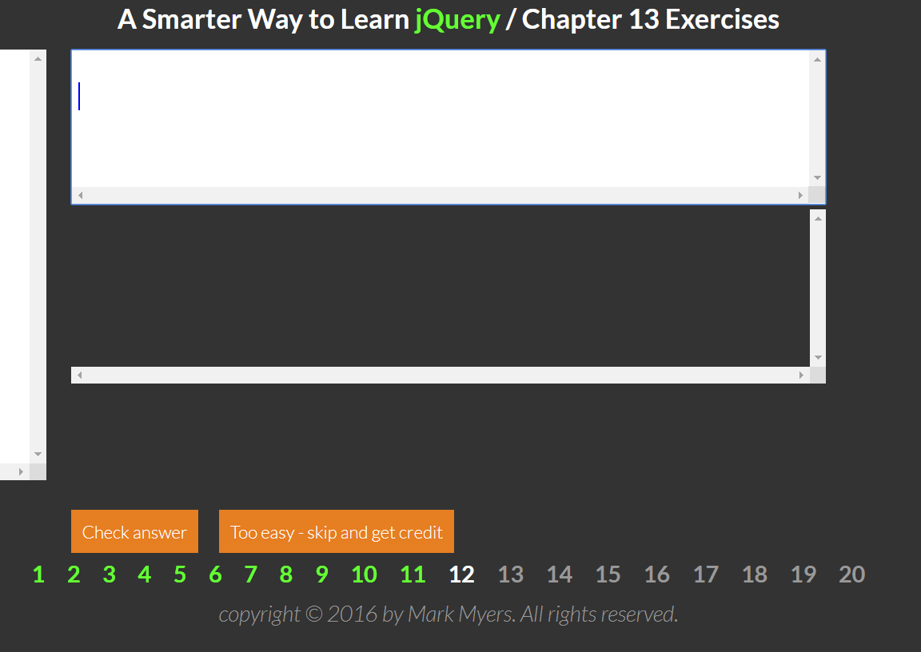

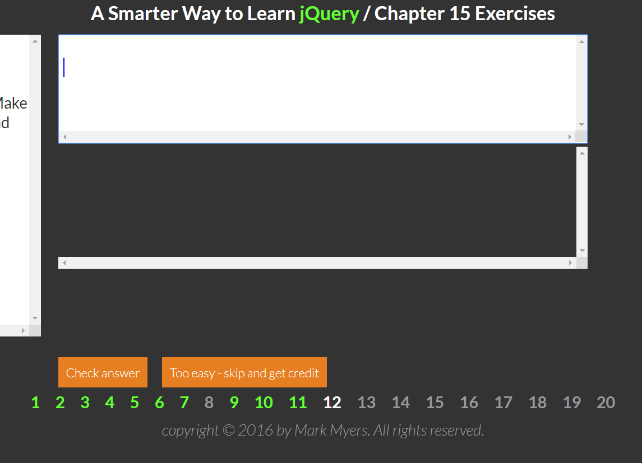

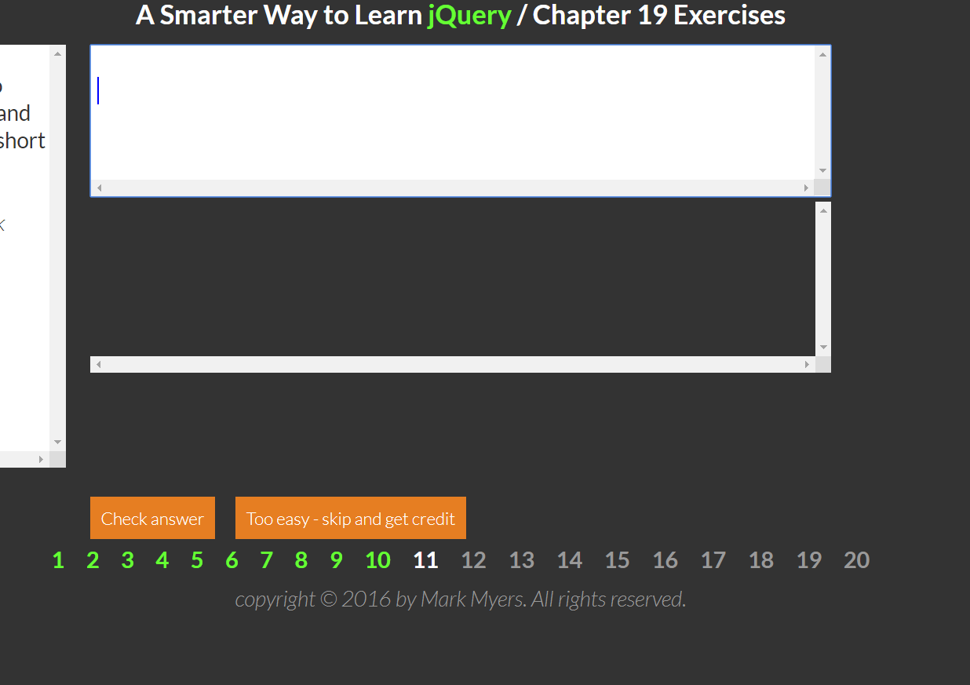

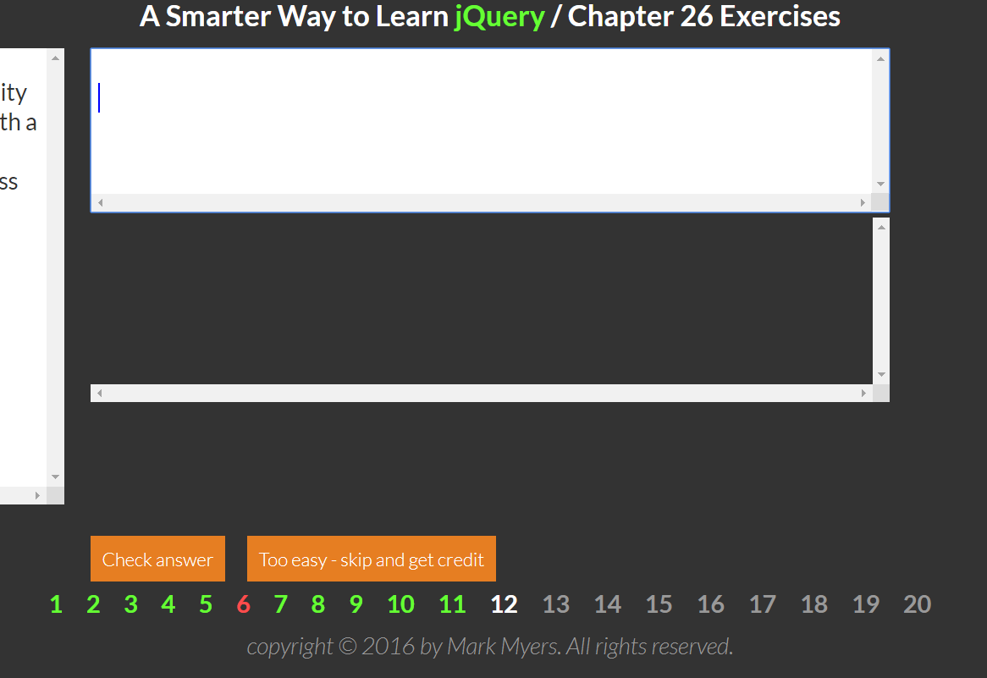

AREA OF RECTANGLE

1. Create 3 text boxes, one to input the length (a) one to input the width (b) and one to output the area (c)
2. Create variables to hold the length (length), width(w). and the result (area).
3. Get the length from text box (a), and assign it to the variable length.
4. Get the width from text box (b), and assign it to the variable width.
5. Calculate length \* width, and assign the result to the variable area.
6. Assign the area to text box (c).